Job Title: | The Network Project Coordinator - Ashley
Responsible to: | The Network Project Manager (based at Barton Hill Settlement).  Internal support/line supervision will be provided by the Farm Director
Responsible for: | Providing support and guidance to identified resident Networkers and volunteers across the Network Project
Place of work: | St Werburghs City Farm
Hours of work: | 21 hours per week (Job Share)
Annual leave: | 25 days plus statutory holidays pro rata
Probationary period: | 6 months
Contract Type: | Fixed Term (until 30th June 2021), subject to BCC Impact Funding
Pay Scale/Salary: | SCP 18-22 £18,870-£21,074 pro rata. Successful candidate starts at the bottom of the scale.
Pensions: | St Werburghs City Farm offers a workplace pension, starting at 3% contributions

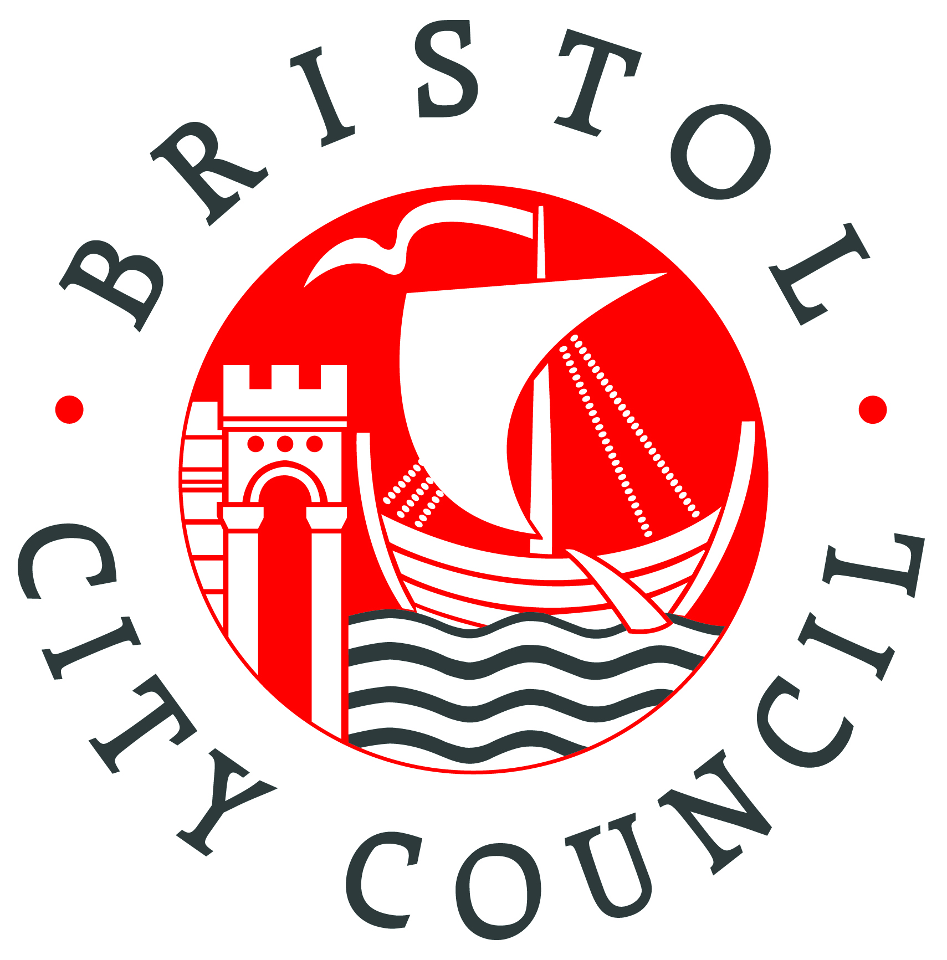
Job Purpose:
The Network Project Coordinator will work as part of a team helping communities to bring about social change and improve the quality of life in the Lawrence Hill, Easton and Ashley wards of Bristol by building inclusive, natural networks and developing sustainable solutions to the challenges faced by people living in these wards. The Network is a partnership made up of Barton Hill Settlement, Somali Resource Centre, St Werburghs City Farm and Wellspring Healthy Living Centre, funded by Bristol City Council’s Impact Fund.

Main Duties & Responsibilities:

Service Delivery:

- Actively engage communities, using a variety of door-to-door or street-to-street methods, in making sense of issues which affect their lives, setting goals for improvement and responding to problems and needs through empowerment and active participation.

- Actively identify community assets, issues and needs and assist in the delivery of training packages to build community skills and resources.

- Recruit and work with identified resident Networkers to devise an individual Activity Plan to achieve personal engagement goals and network with the wider community to achieve wider community goals.

- Implement and adhere to St Werburghs City Farm's (and where relevant, Barton Hill Settlement's) volunteer co-ordination policies and practice.

- Actively encourage participation, challenging inappropriate behaviour, mediating in matters of conflict, developing new resources in dialogue with the community and supporting community-led initiatives.

- Support the building and maintenance of links and networks within communities, both across cultures, geographical boundaries and perceived and actual differences to find commonalities and meaningful ways of working to develop community led activities.

- Liaise with interested groups and individuals to help support the set up of community activities and assist in developing sustainable solutions to the challenges people face.

- Promote the Network Project through a series of Events that engage and recruit participants and celebrate the work of the Network.

- Work in effective partnership with the other members of The Network Project, in particular working as a team with the Lawrence Hill Network Coordinators to deliver Training and Events.

- Liaise regularly with Specialist Advice and Support partners Bristol Somali Resource Centre and Wellspring Healthy Living Centre, helping to ensure that all referrals from partners are included in The Network Project.

- Keep accurate and confidential case notes as well as contributing to the overall effective monitoring of The Network Project by collecting and collating all relevant monitoring information and feedback on the project.

General

- Attend and actively participate in monthly supervision sessions with the Network Project Manager, including engaging in the monitoring and review of performance targets and training needs.

- Work within the procedures of St Werburghs City Farm (and where relevant, Barton Hill Settlement) and attend appropriate in-house and appropriate partner organisation team meetings, training events and staff development days.
- To communicate with staff, volunteers, service users and partners in a positive and effective manner.

- Work flexibly in terms of responsibilities and working hours as required or directed, carrying out any duties as they arise which are consistent with the general character of the post. This post will require some evening and weekend working.

- Promote the aims and objectives of the Farm and present a positive image of the Farm through good public relations, communication with visitors, service users and the local community etc.

- Comply at all times with the Farm’s policies, i.e. Health and Safety, Equal opportunities, Environmental, Confidentiality, Child and Young person’s protection policy etc

- Ensure activities adhere to the Industry Code of Practice, Environmental Health recommendations, Defra regulations and other legislation as appropriate to city farms

- Any other duties commensurate with the post
Person Specification

This part of the job description describes the: knowledge, experience, abilities and skills, and qualification and training.

Applicants must demonstrate that they have the essential criteria in order to be shortlisted for interview. Your application must show, in detail, how you meet the following essential criteria.
It would also be useful to add, in addition, details of how you meet any desirable criteria that may be listed.

Essential criteria
You must describe how you meet these criteria in order to be shortlisted for interview.
- Excellent written and verbal communication, interpersonal and team building skills

- Good knowledge and understanding of local community and social issues, particularly in relation to local disadvantaged and diverse communities.

- An excellent and demonstrative knowledge of the local area.

- Excellent listening skills with a non-judgemental, positive attitude.

- Evidence of creative thinking and problem-solving abilities.

- Excellent engagement, advocacy and networking skills particularly negotiating and facilitating groups of people.

- Experience of designing and delivering training courses.

- A good understanding of maintaining working relationships.

- Ability to work on own initiative and as part of a team and to prioritise need.

- Good organisational, record-keeping and administration skills, IT literate.

- Understanding and experience of reaching out to all communities and an understanding
and commitment to diversity and equalities in all areas of work.

Desirable criteria
1. A community language in addition to English, for example Polish or Somalian.

2. Previous experience of working with or being a volunteer.

This post is subject to a satisfactory DBS check

