AVAA Wildlife and how to support it

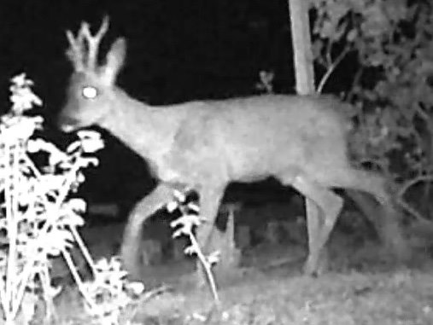
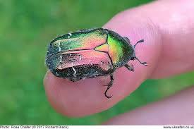

You may see foxes, badgers, deer, mice, rats, lizards, newts, slow worms, frogs and toads, as well as a range of birds and around 15 species of butterfly. Add to this the typical plants and insects of cultivated areas, (weeds and pests to you and me), plus a host of introduced flowers, and shrubs and we have an extremely wild life‐friendly habitat.

You can help keep it this way by:
- Organic Growing
- Respecting your plot borders
- Installing, or looking after a pond
- Supporting pollinators, butterflies, and other insects

AVAA is NOT a wild life conservation area – however there are steps all allotment holders can take to accommodate wild creatures, and plants alongside raising some pretty tasty fruit and veg.

The single most important contribution you can make is to grow organically. Organic gardening is a whole topic on its own, and there are numerous guides. Highly recommended ‐especially for beginners is GOOD EARTH GARDENING, by TIM FOSTER, who has been running organic allotment courses locally for many years. Published by Pomegranate Books, it is available at The Better Food Company and elsewhere.

Your plot borders
Thickets: Bramble thickets and hedges provide vital nesting sites, especially for song birds, such as robins, blackbirds, and wrens. These do not use enclosed nesting boxes and need thick cover in order to avoid the many magpies and crows on site.
Banks should be left alone, be at an angle, and never dug into, or “straightened”. Hot sunny and stony banks with shorter grass support lizards, and slow worms, because the shorter, undisturbed grasses, and stones warm up nicely in the day, and provide basking spots, as well as hiding places and hibernation sites.
The north west border at the top of the site is a designated wild life area, which also provides a safe space for foxes to raise cubs. You will also find Nettle Patches, left for Butterflies

A note on ivy: The ivy thickets on boundary trees provide ivy berries, which support many varieties of birds during the winter; the plant hosts Holly Blue butterflies, and the late flowers are loved by red admirals and peacock butterflies, as well as by many pollinators.

Ponds: Not all allotments need to have ponds, (there are over 40 on the site already), but these provide really useful habitats for toads, newts, damselflies, frogs, dragonflies , pond‐skaters, water snails, water boatmen, and much else besides. Please DO NOT import frog spawn from outside the Site – this can spread fatal diseases.
Basic pond maintenance: In winter clean out dead leaves to keep up oxygen levels, keep water levels up in hot weather/drought, and periodically check for leaks. Clear out excessive blanket weed and duck weed, provide a sloping edge or stones for amphibians to enter and leave the water, and in exposed locations, provide some tall plants to shade your pond.

You can’t have butterflies without having caterpillars!
The Butterfly Conservation Trust has a useful list of caterpillar food plants at: http://butterflyconservation.org/files/caterpillar‐food‐plants.pdf

AVAA most common butterflies and their caterpillar food plants:
Cabbage whites, ie large whites /small whites/green veined whites: will lay eggs on all species of brassicas, (but seem less keen on tougher Calvo nero and Kale). They also like nasturtiums, so net your cabbages and plant some of these easy annuals as a decoy.

Meadow Browns, Ringlets, Speckled Woods, Gatekeepers: The AVAA site was originally farmland meadow, and the tiny grub-like caterpillars of these attractive butterflies feed on the common meadow grasses including couch grass, that surround all our plots. Cutting your edges in rotation, leaving some un‐clipped areas will give the caterpillars a chance. (They won’t move onto your crops‐promise!)

Holly Blues: Holly trees (spring), and then Ivy, (summer) – these lovely butterflies may also use dogwoods and brambles.

Peacocks, Red Admirals; Small Tortoiseshells; Commas -the caterpillars are black/ black and white/ and spiky ‐as well as nettles they like comfrey and hops too!

Pollinators: hover flies, bees, bumble‐bees and more..
We rely on a range of insects to pollinate any of the crops we grow that develop from flowers – these include courgettes, squashes and pumpkins; all varieties of beans; tomatoes, peppers, cucumbers, sweet corn; all types of fruit, (and nuts), and so on.

There is some useful information and an allotment friendly plant list: “Perfect for Allotments” –available from the City Farm Office. Most of the common weeds on the site are good for pollinators too.
